
PROJECT REPORT
ON
“DENTAL CLINIC MANAGEMENT SYSTEM”
SUBMITTED TO
SAMBALPUR UNIVERSITY, ODISHA
FOR THE PARTIAL FULFILLMENT OF
BACHELOR OF COMPUTER APPLICATION
(2017-2020)

SUBMITTED BY
Sagar Kishore Dakua
UNIVERSITY ROLL NO. 3118BCA021
ROURKELA INSTITUTE OF MANAGEMENT STUDIES
ROURKELA-769015

UNDER THE GUIDANCE OF
Prof. Debendra Maharana
ROURKELA INSTITUTE OF MANAGEMENT STUDIES
ROURKELA-769015

ACKNOWLEDGEMENT

I am deeply indebted to RIMS (Rourkela Institute of Management studies), Chhend, Rourkela for providing me an opportunity to undertake a presentation work entitled “Dental Clinic Management System”.
I am grateful to my presentation guide Prof. Debendra Maharana, without his guidance it would not have been possible on my part to complete the project. I express my deep sense of gratitude towards our Lab-in-charge for extending me the necessary permission to do the presentations work on computer laboratory of RIMS during my convenient hours.
Further I would also take an opportunity to thanks all the persons who have guided me in this project.
I consider myself fortunate that I have successfully completed this project; I acknowledge my sincere gratitude to all those authors and researchers whose works had helped me in writing this presentation.
(Sagar Kishore Dakua)
University Roll. No.:3118BCA021

CERTIFICATE

This is to certify that the presentation report entitled “Dental Clinic Management System” developed satisfactorily at the institute by Sagar Kishore Dakua, University roll no.: 3118BCA021 towards the partial fulfillment of Bachelor of Computer Application, session (2017-2020) under the Undergraduate course, Rourkela Institute of Management Studies (affiliated to Sambalpur University, Odisha).

During this period of the presentation of project report, he was found to be sincere and his conduct remained satisfactory.

Place:
Date:

Signature of H.O.D Signature of Internal Guide Signature of external guide

DECLARATION

I do hereby declare that this project report entitled “Dental Clinic Management “has been written and submitted under the guidance of Prof. Debendra Maharana.
This project is result of my own work and has not been submitted in any other institute or university earlier in what so ever form. The information submitted here in is true and original to the best of my knowledge.

Sagar Kishore Dakua

BCA 2nd year

3118BCA021

Date: 23/02/2019

ABSTRACT

This seminar report entitled “Dental Clinic Management” covers the basic; types as well as the advancement in the operating system were described well.

This is a study on types of “Database Technology” & about “Dental Clinic Management”. All the procedures that have been explained are all a part of creating a database for the Dental Clinic.

From Consulting to Booking to Payment, this DBMS helps patient in every angle to take advantage of the services that the Clinic provides.

CONTENTS

- Introduction

- objective

- hardware/software requirement

- system implementation

5. System Design

5.1 Data flow diagram

5.2 E-r diagram

5.3 Form design (Screenshots)

5.4 Database design (table design, normalization)

6. CODES

7. CONCLUSION

INTRODUCTION
The project “Dental Clinic Management System” maintains the
records of all the patients that has consulted or to be consulted in the clinic.

The patients can also book their seat for a visit to the doctor by filling up their details in the booking section of the application.

While booking they have to provide various details such as personal details as well as the purpose for the consultation & further choosing the date & the time on which they wanted to be consulted.

Proceeding further they will be asked to choose a payment method i,e either they can choose to go with Cash on Consult or they can opt for a debit card payment. After that they can submit their application.

This application also has an admin section in which the admin can modify the details of the patients or can add some entries. The admin can finally generate a report regarding the whole data & can print or download.

OBJECTIVES

Input design is the process of converting a user-oriented description of the input into a computer-based system. This design is important to avoid errors in the data input process and show the correct direction to the management for getting correct information from the computerized system.

It is achieved by creating user-friendly screens for the data entry to handle large volume of data. The goal of designing input is to make data easier and to be free from errors. The data entry screen is designed in such a way that all the data manipulates can be performed. It also provides record viewing facilities.

When the data is entered it will check for its validity. Data can be with the help of screens. Appropriate messages provided as when needed so that the user will not be maize of instant. Thus the objective of input design is to create an input layout that is easy to follow.

Hardware/Software Requirements

HARDWARE REQUIREMENTS:

Processor : X86 Compatible processor
With 1.7 GHz Clock speed

RAM : 512 MB or more

Hard disk : 2 GB or more

Monitor : VGA/SVGA

Keyboard : 104 Keys

Mouse : 2 buttons/ 3 buttons

SOFTWARE REQUIREMENTS:

Operating System : Windows 2000/XP/ 7 / 8 / 10
Front end : Visual Basic 6.0
Back end : MS ACCESS

SYSTEM IMPLEMENTATION

About VB 6.0 Language

Before writing an event procedure for the control to response to a user's input, you have to set certain properties for the control to determine its appearance and how it will work with the event procedure. You can set the properties of the controls in the properties window or at runtime. Handling some of the common controls.

The Text Box
The text box is the standard control for accepting input from the user as well as to display the output. It can handle string (text) and numeric data but not images or pictures. String in a text box can be converted to a numeric data by using the function Val(text). The following example illustrates a simple program that processes the input from the user.

The Label
The label is a very useful control for Visual Basic, as it is not only used to provide instructions and guides to the users, it can also be used to display outputs. One of its most important properties is Caption. Using the syntax label.Caption, it can display text and numeric data . You can change its caption in the properties window and also at runtime. Please refer to Example 3.1 and Figure 3.1 for the usage of label.

The Command Button
The command button is one of the most important controls as it is used to execute commands. It displays an illusion that the button is pressed when the user click on it. The most common event associated with the command button is the Click event, and the syntax for the procedure is

Private Sub Command1_Click ()

Statements

End Sub

The Image Box
The Image Box is another control that handles images and pictures. It functions almost identically to the picture box. However, there is one major difference, the image in an Image Box is stretchable, which means it can be resized. This feature is not available in Image Box is stretchable, which means it can be resized. This feature is not available in the Picture Box. Similar to the Picture Box, it can also use the LoadPicture method to load the picture. For example, the statement loads the picture grape.gif into the image box.

Image1.Picture=LoadPicture ("C:\VB program\Images\grape.gif").

The Combo Box
The function of the Combo Box is also to present a list of items where the user can click and select the items from the list. However, the user needs to click on the small arrowhead on the right of the combo box to see the items which are presented in a drop-down list. In order to add items to the list, you can also use the AddItem method. For example, if you wish to add a number of items to Combo box 1, you can key in the following statements:

Example:

Private Sub Form_Load ( )

Combo1.AddItem “Item1”

Combo1.AddItem “Item2”

Combo1.AddItem “Item3”

Combo1.AddItem “Item4”

End Sub

The Check Box
The Check Box control lets the user selects or unselects an option. When the Check Box is checked, its value is set to 1 and when it is unchecked, the value is set to 0. You can include the statements Check1.Value=1 to mark the Check Box and Check1.Value=0 to unmark the Check Box, as well as use them to initiate certain actions. For example, the program will change the background color of the form to red when the check box is unchecked and it will change to blue when the check box is checked. You will learn about the conditional statement If….Then….Elesif in later lesson. VbRed and vbBlue are color constants and BackColor is the background color property of the form.

The Option Box
The Option Box control also lets the user selects one of the choices. However, two or more Option Boxes must work together because as one of the Option Boxes is selected, the other Option Boxes will be unselected. In fact, only one Option Box can be selected at one time. When an option box is selected, its value is set to “True” and when it is unselected; its value is set to “False”. In the following example, the shape control is placed in the form together with six Option Boxes. When the user clicks on different option boxes, different shapes will appear. The values of the shape control are 0, 1, and 2,3,4,5 which will make it appear as a rectangle, a square, an oval shape, a rounded rectangle and a rounded square respectively.

Example
Private Sub Option1_Click ( )
Shape1.Shape = 0
End Sub
Private Sub Option2_Click()
Shape1.Shape = 1
End Sub
Private Sub Option3_Click()
Shape1.Shape = 2
End Sub
End Sub
Private Sub Option4_Click()
Shape1.Shape = 3
End Sub
Private Sub Option5_Click()
Shape1.Shape = 4
End Sub
Private Sub Option6_Click()
Shape1.Shape = 5
End Sub
MS ACCESS 2003
Microsoft Access is a powerful program to create and manage your databases. It has many built in features to assist you in constructing and viewing your information. Access is much more involved and is a more genuine database application than other programs such as Microsoft Works.

The keywords involved in the process are: Database File, Table, Record, Field, Data-type.

Here is the Hierarchy that Microsoft Access uses in breaking down a database.
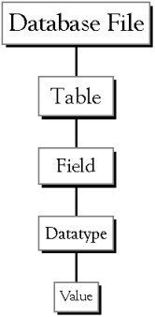
Database File: This is your main file that encompasses the entire database and that is saved to your hard-drive or floppy disk.

Example: StudentDatabase.mdb
Table:A table is a collection of data about a specific topic. There can be multiple tables in a database.

Field: Fields are the different categories within a Table. Tables usually contain multiple fields.

Datatypes: Datatypes are the properties of each field. A field only has 1 datatype.
FieldName) Student LastName

Starting Microsoft Access
- Two Ways

  - Double click on the Microsoft Access icon on the desktop.

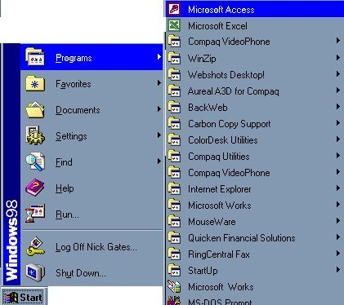
  - Click on Start --> Programs --> Microsoft Access

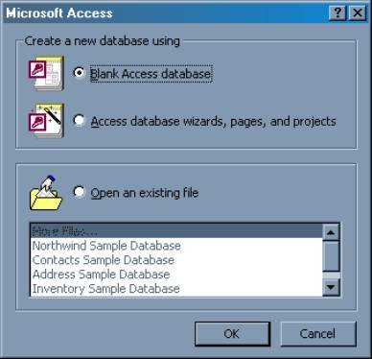
- Creating New, and Opening Existing Databases

The above picture gives you the option to:
Create a New Database from scratch

- Use the wizard to create a New Database
- Open an existing database
The white box gives you the most recent databases you have used.If you do not see the one you had created, choose the More Files option and hit OK. Otherwise choose the database you had previously used and click OK.
DATA FLOW DIAGRAM
A data-flow diagram(DFD) is a graphical representation of the “flow” of data through an information system. DFDs can also be used for the visualization of data processing (structured design).

A DFDs provides no information about the timing or ordering of processes, or about whether processes will operate in sequence or in parallel. Data-flow diagrams can be used to provide the end user with a physical idea of where the data the input ultimately has an effect upon the structure of the hole system from order to dispatch to report. How any system is developed can be determined through a data flow diagram.

The circle or bubble represents a transformation process and the label inside the bubble describes the process using an active verb. Data flows are directed lines that identify the input data flows and output data flows at each process
bubble.

Data storage is represented by an open – ended rectangle with a label that identify the data store or file. The square is labeled to identify an external entity that is a source or destination of data flow.

Data flow diagram is used to define the flow of the system and its resources such as information’s. DFD are away of expressing system requirements in a graphical manner.

DFD represent one of the most ingenious tools use for structure analysis. It has the purpose of clarifying system requirements and identifying major transformation that will become programs in the system design.

It is a major point in the design phase that functionality decomposes the requirements specification down the lowest level of detail.

There are two types of DFDs. They are:
- Physical DFD
- Logical DFD

Physical DFD: These are implementation dependent view of current system showing what task is carried out and how they are performed. they show the actual devices, departments people etc…. involved in the current system. Physical characteristics include:
1.Name of the file.
2.Functions descriptions.
3.Name of the controls.
4.Controls properties.
5.Name of the project.

Logical DFD: An implementation – independent view of the system, focusing on the flow of data between processes without regard for a specific device, storage location or people in the system.
Advantage
- Users easily understand simple notation.
- Users can make suggestions for modifications.
- They can also spot problem quickly.

Basic data flow diagram symbols

Packets of data to travel from one point to another. Data may flow from a source to a process and from data store or process. An arrow line depicts the flow, with arrow head pointing in the direction of the flow.

Circles stands for process that converts data into information. A process represents transformation where incoming data flows. A data flow is a rout which enables are changing into outgoing data flows.

A data store is a repository of data that is to be stored for use by a one or more process may be as simple as buffer or queue or sophisticated as relational data base. They should have clear names. If a process merely uses the content of store and does not alter it, the arrowhead goes only from the store to the process. If a process alters the details in the store then a double headed arrow is used.

A source or sink is a person or part of an organization which enter or receives information from the system, but is considered to be outside the contest of data flow model.

DFD DIAGRAM
LEVEL 0 DFD

Username
Password
User /Admin

Consultation Form
Payment Enquiry
Booking Form

Password
Admin
Admin Login

LEVEL 1 DFD
User /Admin
Password
Username
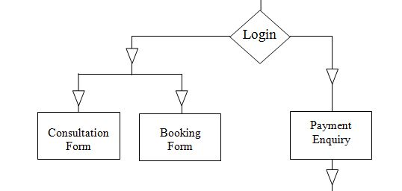

Password
Admin
Admin Login
Payment gateway
Submit

Patient_Info
Consult_Info
Booking_Info
Payment_Info

Entity Relationship Diagram
An entity relationship diagram (ERD) shows the relationships of entity sets stored in a database. An entity in this context is a component of data. In other words, ER diagrams illustrate the logical structure of databases.
At first glance an entity relationship diagram looks very much like a flowchart. It is the specialized symbols, and the meanings of those symbols, that make it unique.

Common Entity Relationship Diagram Symbols:
An ER diagram is a means of visualizing how the information a system produces is related. There are five main components of an ERD:
- Entities, which are represented by rectangles. An entity is an object or concept about which you want to store information.
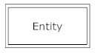

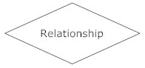
- An entity that must defined by a foreign key relationship with another entity as it cannot be uniquely identified by its own attributes alone.

- Actions, which are represented by diamond shapes, show how two entities share information in the database. In some cases, entities can be self-linked. For example, employees can supervise other employees.
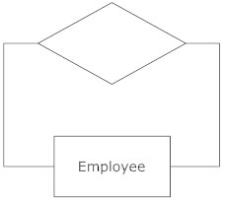

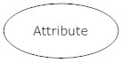
- Attributes, which are represented by ovals. A key attribute is the unique, distinguishing characteristic of the entity. For example, an employee's social security number might be the employee's key attribute.

A multivalued attribute can have more than one value. For example, an employee entity can have multiple skill values. A derived attribute is based on another attribute. For example, an employee's monthly salary is based on the employee's annual salary.
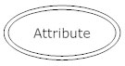

- Connecting lines, solid lines that connect attributes to show the relationships of entities in the diagram.

- Cardinality specifies how many instances of an entity relate to one instance of another entity. Cardinality is also closely linked to cardinality. While cardinality specifies the occurrences of a relationship, Cardinality describes the relationship as either mandatory or optional. In other words, cardinality specifies the maximum number of relationships and Cardinality specifies the absolute minimum number of relationships.

Entity Relationship Diagram of Dental Clinic Management System
Firstname
Password
Firstname
Patient_Info
Username
Gender
Email
1
Country
Consult_Info
Opts
n
Gender
Day1
Year1
Mobile
n
Month1
Problem
Booking_Info
Consult_time
n
Takes
Name_of_Payee
Payment
Payment_Info
n

System Design
Design is the first step into the development phase for any engineered product or system. Design is a creative process. A good design is the key to effective system.

The term “design” is defined as “the process of applying various techniques and principles for the purpose of defining a process or a system in sufficient detail to permit its physical realization”.

It may be defined as a process of applying various techniques and principles for the purpose of defining a device, a process or a system in sufficient detail to permit its physical realization.

Software design sits at the technical kernel of the software engineering process and is applied regardless of the development paradigm that is used. The system design develops the architectural detail required to build a system or product.

As in the case of any systematic approach, this software too has undergone the best possible design phase fine tuning all efficiency, performance and accuracy levels.

The design phase is a transition from a user oriented document to a document to the programmers or database personnel.

System design goes through two phases of development: Logical and Physical Design.

LOGINFORM
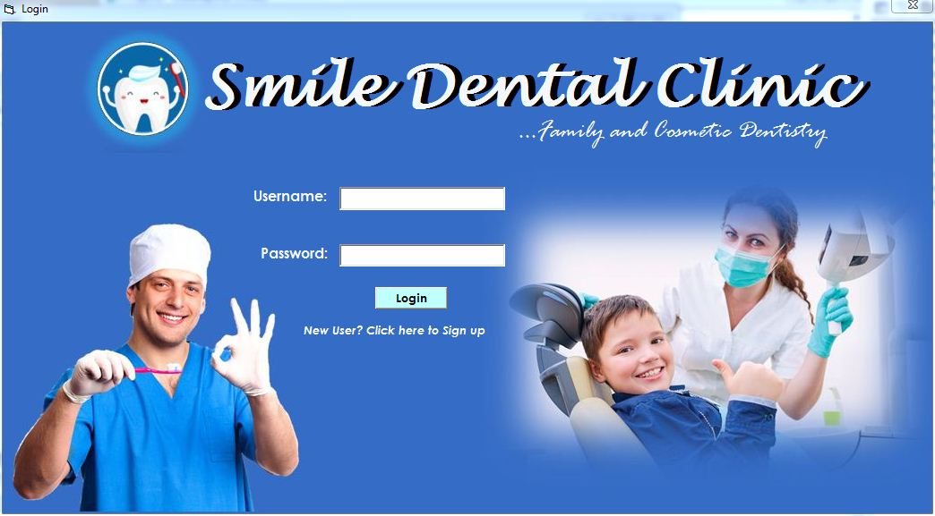

SIGNUP FORM
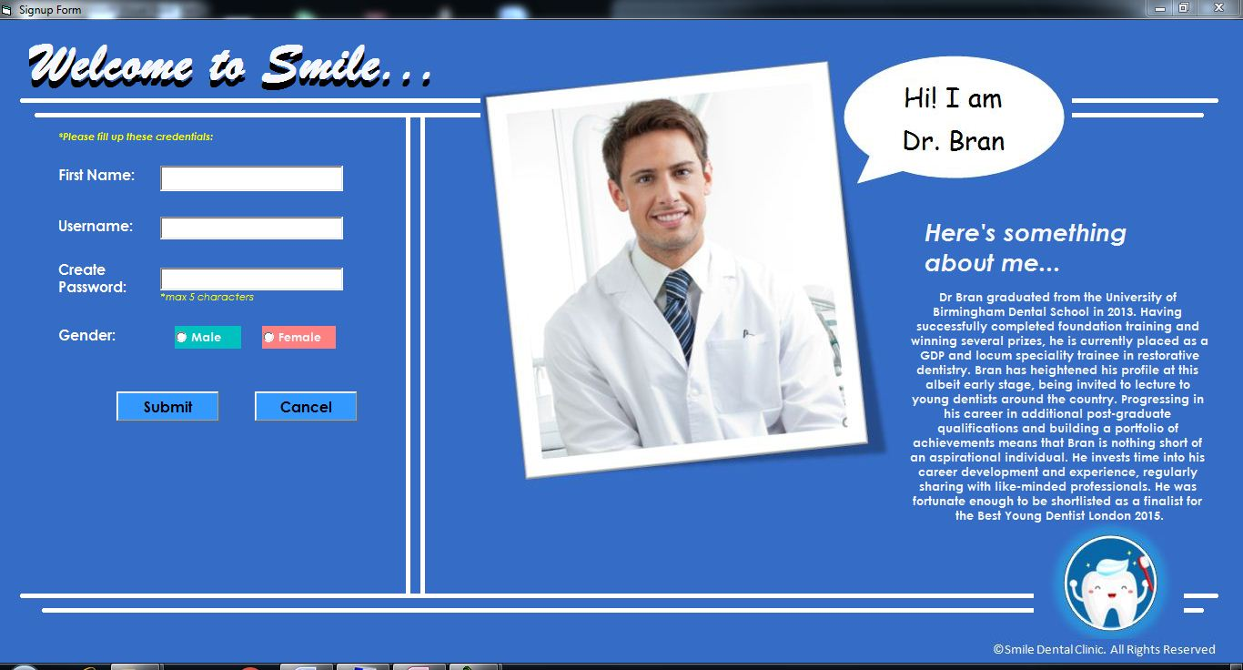

HOMEPAGE


CONTACT US
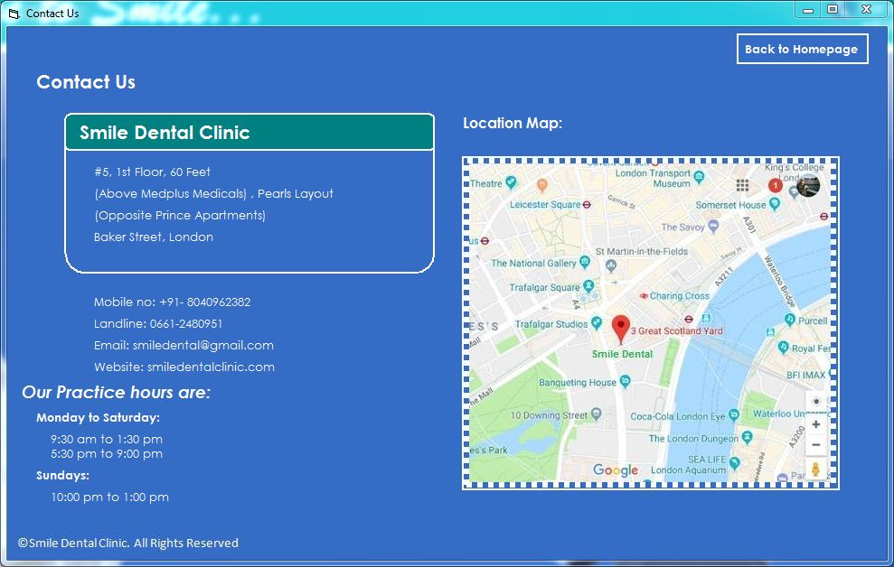

CONSULTATION FORM
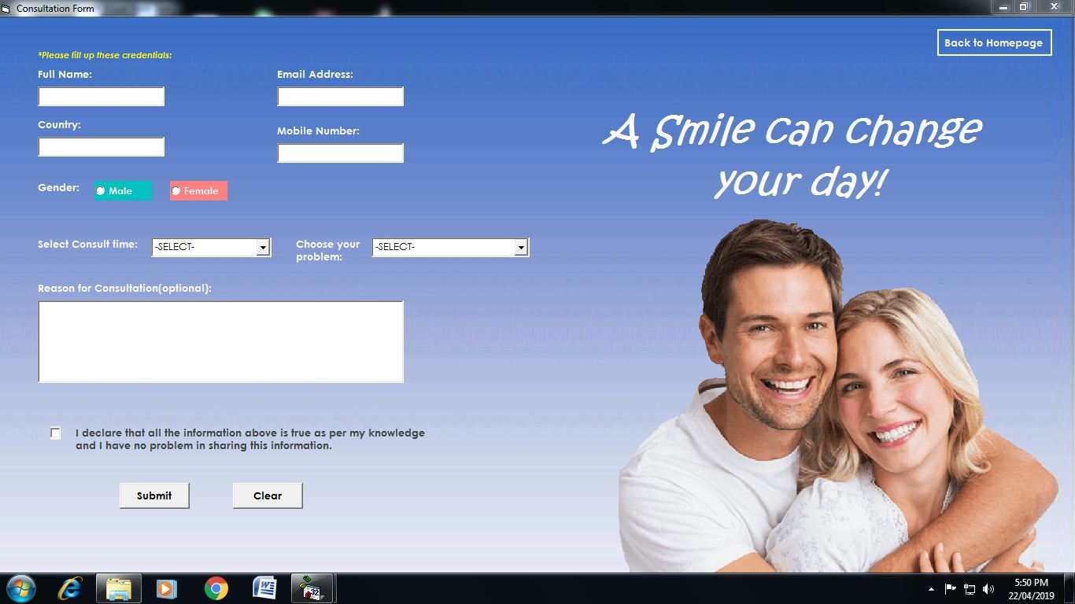

BOOKING FORM
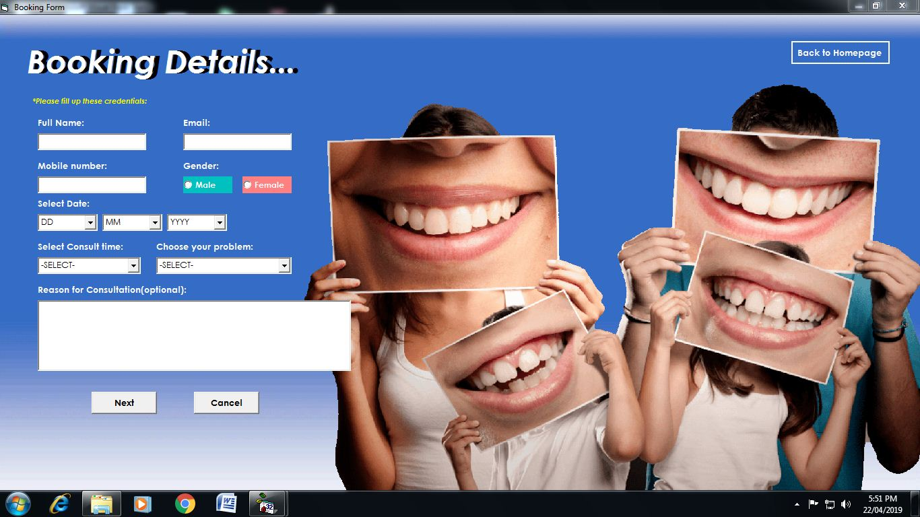

PAYMENT METHOD
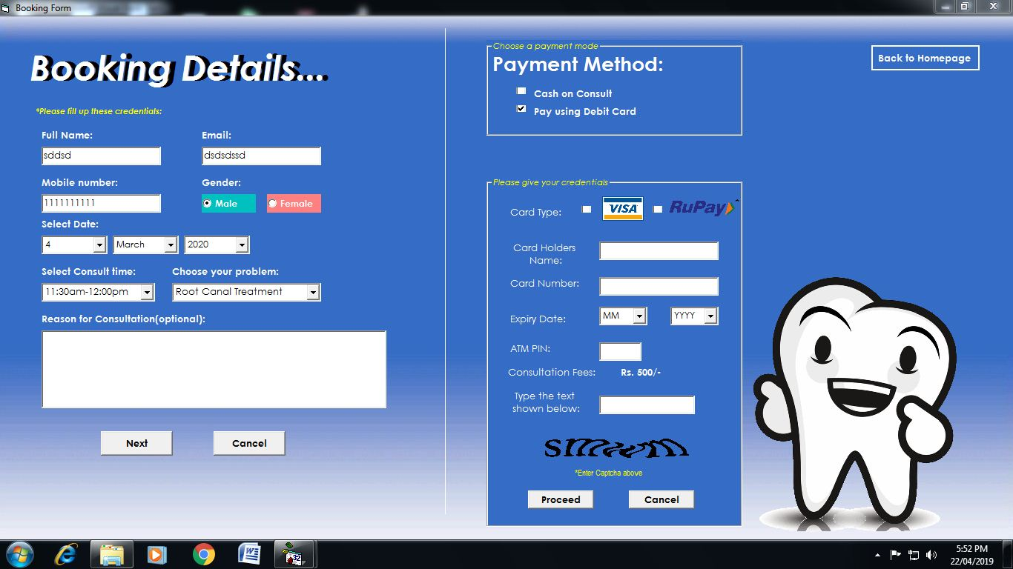

Database Design
A database is an organized mechanism that has the capability of storing information through which a user can retrieve stored information in an effective and efficient manner. The data is the purpose of any database and must be protected.

The database design is a two level process. In the first step, user requirements are gathered together and a database is designed which will meet these requirements as clearly as possible. This step is called Information Level Design and it is taken independent of any individual DBMS.

In the second step, this Information level design is transferred into a design for the specific DBMS that will be used to implement the system in question. This step is called Physical Level Design, concerned with the characteristics of the specific DBMS that will be used. A database design runs parallel with the system design. The organization of the data in the database is aimed to achieve the following two major objectives.

- Data Integrity
- Data independence

Normalization is the process of decomposing the attributes in an application, which results in a set of tables with very simple structure. The purpose of normalization is to make tables as simple as possible. Normalization is carried out in this system for the following reasons.

- To structure the data so that there is no repetition of data , this helps in saving.
- To permit simple retrieval of data in response to query and report request.
- To simplify the maintenance of the data through updates, insertions, deletions.
- To reduce the need to restructure or reorganize data which new application requirements arise.

RELATIONAL DATABASE MANAGEMENT SYSTEM (RDBMS):

A relational model represents the database as a collection of relations. Each relation resembles a table of values or file of records. In formal relational model terminology, a row is called a tuple, a column header is called an attribute and the table is called a relation. A relational database consists of a collection of tables, each of which is assigned a unique name. A row in a tale represents a set of related values.

RELATIONS, DOMAINS & ATTRIBUTES:

A table is a relation. The rows in a table are called tuples. A tuple is an ordered set of n elements. Columns are referred to as attributes. Relationships have been set between every table in the database. This ensures both Referential and Entity Relationship Integrity. A domain D is a set of atomic values. A common method of specifying a domain is to specify a data type from which the data values forming the domain are drawn. It is also useful to specify a name for the domain to help in interpreting its values. Every value in a relation is atomic, that is not decomposable.

- RELATIONSHIPS: Table relationships are established using Key. The two main keys of prime importance are Primary Key & Foreign Key. Entity Integrity and Referential Integrity Relationships can be established with these keys. Entity Integrity enforces that no Primary Key can have null values. Referential Integrity enforces that no Primary Key can have null values

- Referential Integrity for each distinct Foreign Key value, there must exist a matching Primary Key value in the same domain. Other key are Super Key and Candidate Keys.Relationships have been set between every table in the database. This ensures both Referential and Entity Relationship Integrity.

NORMALIZATION:

As the name implies, it denoted putting things in the normal form. The application developer via normalization tries to achieve a sensible organization of data into proper tables and columns and where names can be easily correlated to the data by the user. Normalization eliminates repeating groups at data and thereby avoids data redundancy which proves to be a great burden on the computer resources. These includes:

- Normalize the data.
- Choose proper names for the tables and columns.
- Choose the proper name for the data.

First Normal Form:

The First Normal Form states that the domain of an attribute must include only atomic values and that the value of any attribute in a tuple must be a single value from the domain of that attribute. In other words 1NF disallows “relations within relations” or “relations as attribute values within tuples”. The only attribute values permitted by 1NF are single atomic or indivisible values.

The first step is to put the data into First Normal Form. This can be donor by moving data into separate tables where the data is of similar type in each table. Each table is given a Primary Key or Foreign Key as per requirement of the project. In this we form new relations for each nonatomic attribute or nested relation. This eliminated repeating groups of data.

A relation is said to be in first normal form if only if it satisfies the constraints that contain the primary key only.

Second Normal Form:

According to Second Normal Form, For relations where primary key contains multiple attributes, no nonkey attribute should be functionally dependent on a part of the primary key.

In this we decompose and setup a new relation for each partial key with its dependent attributes. Make sure to keep a relation with the original primary key and any attributes that are fully functionally dependent on it. This step helps in taking out data that is only dependant on apart of the key.

A relation is said to be in second normal form if and only if it satisfies all the first normal form conditions for the primary key and every non-primary key attributes of the relation is fully dependent on its primary key alone.

Third Normal Form:

According to Third Normal Form, Relation should not have a non key attribute functionally determined by another non key attribute or by a set of non key attributes. That is, there should be no transitive dependency on the primary key.
In this we decompose and set up relation that includes the non key attributes that functionally determines other non key attributes. This step is taken to get rid of anything that does not depend entirely on the Primary Key. a key in normal form and more over the non key attributes of the relation should not be depend on other non key attribute.

TABLE DESIGN
Table: Patient_Info:
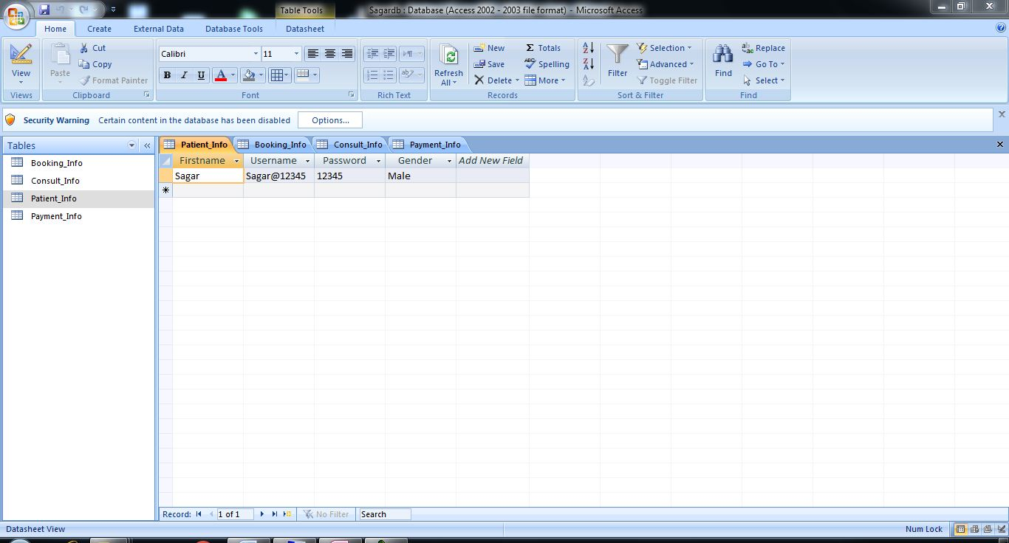

Consult_Info:
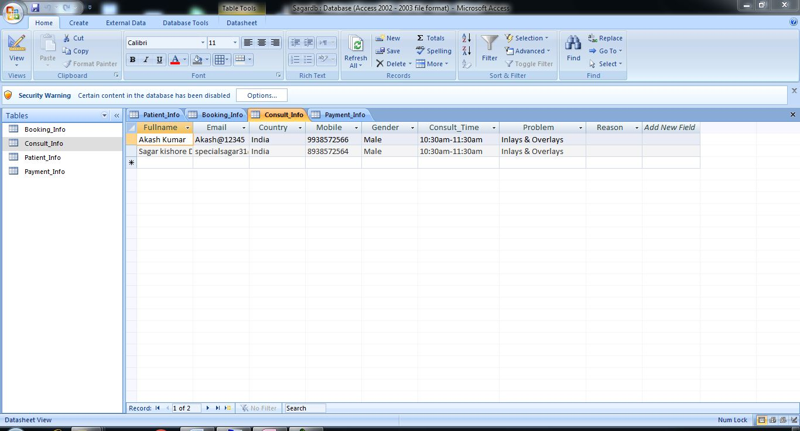

Booking_Info:
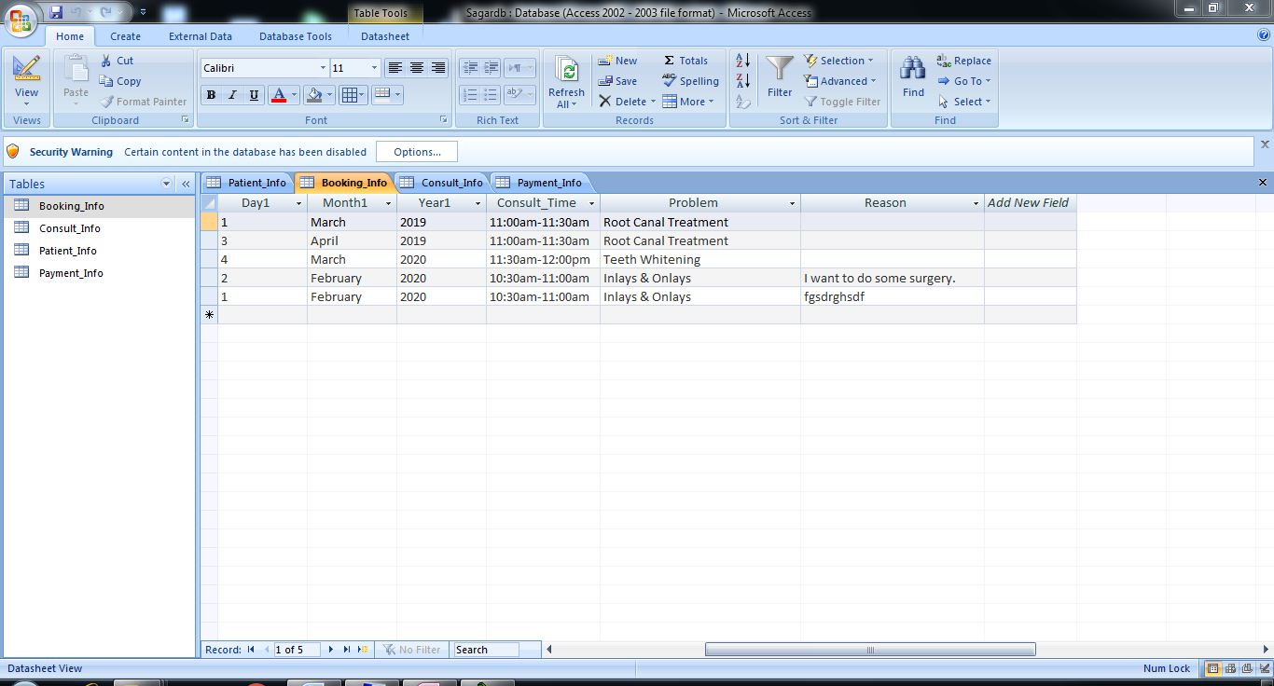

Payment_Info:
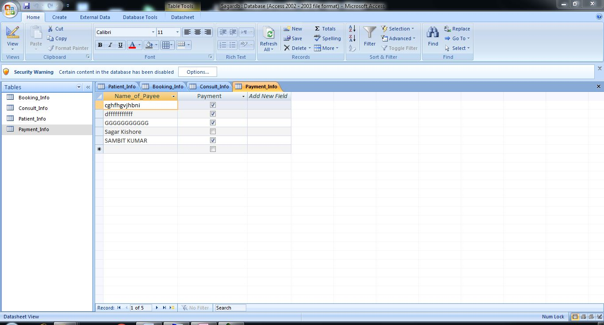

Codes
USER LOG IN
Dim con As New ADODB.Connection
Dim rs As New ADODB.Recordset
Dim sql1 As String
Private Sub Command1_Click()
Dim m
If Text1.Text = "" Then
MsgBox "Enter Username"
Text1.SetFocus
ElseIf Text2.Text = "" Then
MsgBox "Enter your Password"
Else
sql1 = "select * from Patient_Info"
con.Open "Provider= Microsoft.JET.OLEDB.4.0;Data source= D:\Sagardb.mdb"
rs.Open sql1, con, adOpenDynamic, adLockOptimistic, adCmdText
Do Until rs.EOF
If Text1.Text = rs!UserName And Text2.Text = rs!Password Then
Unload Me
Form3.Show
rs.Close
con.Close
Exit Sub
End If
rs.MoveNext
Loop
m = MsgBox("Login Unsuccessful. You have either entered Username or Password Incorrect. Please Try Again", vbOKCancel, "Message")
Text1.Text = ""
Text2.Text = ""
Text1.SetFocus
rs.Close
con.Close
End If
End Sub
Main page
Private Sub Form_Load()
Form3.BackColor = RGB(53, 109, 198)
End Sub
Private Sub Image5_Click()
End Sub
Private Sub Label2_Click()
Form4.Show
End Sub
Private Sub Label4_Click()
Dim MSG As String
MSG = MsgBox("Are You Sure you want to Logout?", vbYesNo, "Logout Confirmation")
If MSG = vbYes Then
Unload Me
Form1.Show
End If
End Sub
Private Sub Label5_Click()
Dim MSG As String
MSG = MsgBox("Payment Enquiry needs Administrator Login. Do you want to login as an admin?", vbYesNo, "Requires Admin Login")
If MSG = vbYes Then
Form7.Show
End If
End Sub
Private Sub Label7_Click()
Unload Me
Form5.Show
End Sub
Private Sub Label8_Click()
Unload Me
Form6.Show
EndSub
Signup form
Dim con As New ADODB.Connection
Dim rs As New ADODB.Recordset
Dim sql1 As String

Private Sub Command1_Click()
If Text1.Text = "" Then
MsgBox "Please enter First Name"
Text1.SetFocus
ElseIf Text2.Text = "" Then
MsgBox ("Please enter Username")
Text2.SetFocus
ElseIf Text3.Text = "" Then
MsgBox "Please create a Password"
Text3.SetFocus
ElseIf Option1.Value = False And Option2.Value = False Then
MsgBox "Please choose Gender"
Else
sql1 = "select*from Patient_Info"
con.Open "Provider=Microsoft.JET.OLEDB.4.0;data source=d:\Sagardb.mdb"
rs.Open sql1, con, adOpenDynamic, adLockOptimistic, adCmdText
rs.AddNew
rs!Firstname = Text1.Text
rs!UserName = Text2.Text
rs!Password = Text3.Text
If Option1.Value = True Then
rs!Gender = "Male"
ElseIf Option2.Value = True Then
rs!Gender = "Female"
End If
rs.Update
MsgBox ("Welcome" & " " & Text1.Text & " to Smile")
Text1.Text = ""
Text2.Text = ""
Text3.Text = ""
Option1.Value = False
Option2.Value = False
rs.Close
con.Close
Form1.Show
Unload Me
End If
End Sub
Consultation form
Dim con As New ADODB.Connection
Dim rs As New ADODB.Recordset
Dim sql1 As String

Private Sub Command1_Click()
If Text1.Text = "" Then
MsgBox "Please enter Full Name", vbOKOnly + vbExclamation, "Message"
Text1.SetFocus
ElseIf Text2.Text = "" Then
MsgBox "Please enter your email address", vbOKOnly + vbExclamation, "Message"
Text2.SetFocus
ElseIf Text3.Text = "" Then
MsgBox "Please choose your country", vbOKOnly + vbExclamation, "Message"
Text3.SetFocus
ElseIf Text4.Text = "" Then
MsgBox "Please provide your contact number", vbOKOnly + vbExclamation, "Message"
Text4.SetFocus
ElseIf Option1.Value = False And Option2.Value = False Then
MsgBox "Please choose your Gender", vbOKOnly + vbExclamation, "Message"
ElseIf Combo1.Text = "-SELECT-" Then
MsgBox "Please choose a time period to consult", vbOKOnly + vbExclamation, "Message"
ElseIf Combo2.Text = "-SELECT-" Then
MsgBox "Please choose a problem to consult", vbOKOnly + vbExclamation, "Message"
ElseIf Check1 = False Then
MsgBox "You have missed something", vbOKOnly + vbExclamation, "Message"
Else
sql1 = "select*from Consult_Info"
con.Open "Provider=Microsoft.JET.OLEDB.4.0;data source=d:\Sagardb.mdb"
rs.Open sql1, con, adOpenDynamic, adLockOptimistic, adCmdText
rs.AddNew
rs!Fullname = Text1.Text
rs!Email = Text2.Text
rs!Country = Text3.Text
rs!Mobile = Text4.Text
If Option1.Value = True Then
rs!Gender = "Male"
ElseIf Option2.Value = True Then
rs!Gender = "Female"
End If
rs!Consult_Time = Combo1.Text
rs!Problem = Combo2.Text
rs!Reason = Text5.Text
rs.Update
MsgBox ("Dear" & " " & Text1.Text & " your consultation has been set on " & Combo1.Text)
Text1.Text = ""
Text2.Text = ""
Text3.Text = ""
Text4.Text = ""
Option1.Value = False
Option2.Value = False
rs.Close
con.Close
Form3.Show
Unload Me
End If
End Sub
Private Sub Command2_Click()
Text1.Text = ""
Text2.Text = ""
Text3.Text = ""
Text4.Text = ""
Option1 = False
Option2 = False
Combo1.Text = "-SELECT-"
Combo2.Text = "-SELECT-"
Text5.Text = ""
Check1 = False
Text1.SetFocus
End Sub
Private Sub Combo2_DropDown()
Combo2.AddItem "-SELECT-"
Combo2.AddItem "Inlays & Onlays"
Combo2.AddItem "Root Canal Treatment"
Combo2.AddItem "Teeth Whitening"
Combo2.AddItem "Complete Dentures"
Combo2.AddItem "Cosmetic Dentistry"
Combo2.AddItem "Crowns & Bridges"
Combo2.AddItem "Dental Implants"
Combo2.AddItem "Oral & Maxillofacial Surgery"
Combo2.AddItem "Orthodontic Treatment"
Combo2.AddItem "Other general treatments"
End Sub
Private Sub Form_Load()
Form5.BackColor = RGB(53, 109, 198)
Combo1.AddItem "-SELECT-"
Combo1.AddItem "10:30am -11:00am"
Combo1.AddItem "11:00am -11:30am"
Combo1.AddItem "11:30am -12:00pm"
Combo1.AddItem "12:00pm -12:30pm"
Combo1.AddItem "12:30pm -01:00pm"
End Sub
Private Sub Label11_Click()
Dim MSG As String
MSG = MsgBox("Are you sure you want to cancel your consultation?", vbYesNo, "Cancel")
If MSG = vbYes Then
Form3.Show
Unload Me
End If
End Sub
Booking form
Dim con As New ADODB.Connection
Dim rs As New ADODB.Recordset
Dim sql1 As String
Private Sub Check1_Click()
If Check1.Value = 1 Then
Check2.Value = False
Command5.Visible = True
Command6.Visible = True
Image6.Visible = True
ElseIf Check1.Value = 0 Then
Command5.Visible = False
Command6.Visible = False
End If
End Sub

Private Sub Check2_Click()
If Check2.Value = 1 Then
Check1.Value = False
Frame1.Visible = True
Image4.Visible = True
Image6.Visible = False
Else
Frame1.Visible = False
Image4.Visible = False
Image6.Visible = True
End If
End Sub

Private Sub Check3_Click()
If Check3.Value = 1 Then
Check4.Value = False
End If
End Sub

Private Sub Check4_Click()
If Check4.Value = 1 Then
Check3.Value = False
End If
End Sub

Private Sub Combo1_KeyPress(KeyAscii As Integer)
Select Case KeyAscii
Case 8
Case Else
KeyAscii = 0
End Select
End Sub
Private Sub Combo2_KeyPress(KeyAscii As Integer)
Select Case KeyAscii
Case 8
Case Else
KeyAscii = 0
End Select
End Sub
Private Sub Combo3_KeyPress(KeyAscii As Integer)
Select Case KeyAscii
Case 8
Case Else
KeyAscii = 0
End Select
End Sub
Private Sub Combo4_KeyPress(KeyAscii As Integer)
Select Case KeyAscii
Case 8
Case Else
KeyAscii = 0
End Select
End Sub
Private Sub Combo5_KeyPress(KeyAscii As Integer)
Select Case KeyAscii
Case 8
Case Else
KeyAscii = 0
End Select
End Sub
Private Sub Combo6_KeyPress(KeyAscii As Integer)
Select Case KeyAscii
Case 8
Case Else
KeyAscii = 0
End Select
End Sub
Private Sub Combo7_KeyPress(KeyAscii As Integer)
Select Case KeyAscii
Case 8
Case Else
KeyAscii = 0
End Select
End Sub

Private Sub Command1_Click()
If Check3.Value = False And Check4.Value = False Then
MsgBox "Please choose your card type."
ElseIf Text8.Text = "" Then
MsgBox "Enter the name as on your debit card."
ElseIf Text4.Text = "" Then
MsgBox "Enter your card number."
ElseIf Len(Trim(Text4.Text)) <> 16 Then
MsgBox "Please enter your 16-digit card number"
ElseIf Combo6.Text = "MM" Then
MsgBox "Please choose expiry month"
ElseIf Combo7.Text = "YYYY" Then
MsgBox "Please choose expiry year"
ElseIf Text6.Text = "" Then
MsgBox "Please enter your 4-digit ATM PIN"
ElseIf Len(Trim(Text6.Text)) < 4 Then
MsgBox "Please enter correct 4-digit ATM PIN"
ElseIf Text7.Text <> "smwm" Then
MsgBox "Invalid Captcha"
Else
sql1 = "select*from Payment_Info"
con.Open "Provider=Microsoft.JET.OLEDB.4.0;data source=d:\Sagardb.mdb"
rs.Open sql1, con, adOpenDynamic, adLockOptimistic, adCmdText
rs.AddNew
rs!Name_of_Payee = Text8.Text
rs!Payment = True
rs.Update
rs.Close
con.Close
Dim MSG As String
MSG = MsgBox("Thanks for using your debit card. Click on YES to confirm your booking.", vbYesNo, "Payment Successful")
If MSG = vbYes Then

sql1 = "select*from Booking_Info"
con.Open "Provider=Microsoft.JET.OLEDB.4.0;data source=d:\Sagardb.mdb"
rs.Open sql1, con, adOpenDynamic, adLockOptimistic, adCmdText
rs.AddNew
rs!Fullname = Text1.Text
rs!Email = Text2.Text
rs!Mobile = Text3.Text
If Option1.Value = True Then
rs!Gender = "Male"
ElseIf Option2.Value = True Then
rs!Gender = "Female"
End If
rs!Day1 = Combo1.Text
rs!Month1 = Combo2.Text
rs!Year1 = Combo3.Text
rs!Consult_Time = Combo4.Text
rs!Problem = Combo5.Text
rs!Reason = Text5.Text
rs.Update
MsgBox ("Dear" & " " & Text1.Text & " your Booking has been confirmed. Be ready for your consultation on " & Combo1.Text & "-" & Combo2.Text & "-" & Combo3.Text & " " & " on " & Combo4.Text)
Text1.Text = ""
Text2.Text = ""
Text3.Text = ""
Option1.Value = False
Option2.Value = False
rs.Close
con.Close
Form3.Show
Unload Me
End If
End If
End Sub

Private Sub Command2_Click()
Dim MSG As String
MSG = MsgBox("Are you sure you want to cancel your booking?", vbYesNo, "Cancel")
If MSG = vbYes Then
Form3.Show
Unload Me
End If
End Sub

Private Sub Command3_Click()
If Text1.Text = "" Then
MsgBox "Please enter Full Name.", vbOKOnly + vbExclamation, "Message"
Text1.SetFocus
ElseIf Text2.Text = "" Then
MsgBox "Please enter your email address.", vbOKOnly + vbExclamation, "Message"
Text2.SetFocus
ElseIf Text3.Text = "" Then
MsgBox "Please enter your mobile.", vbOKOnly + vbExclamation, "Message"
Text3.SetFocus
ElseIf Len(Trim(Text3.Text)) < 10 Then
MsgBox "Please enter correct 10-digit Mobile Number", vbOKOnly + vbExclamation, "Message"
Text3.SetFocus
ElseIf Option1.Value = False And Option2.Value = False Then
MsgBox "Please choose your Gender.", vbOKOnly + vbExclamation, "Message"
ElseIf Combo1.Text = "DD" Then
MsgBox "Please choose a day.", vbOKOnly + vbExclamation, "Message"
ElseIf Combo2.Text = "MM" Then
MsgBox "Please choose a month.", vbOKOnly + vbExclamation, "Message"
ElseIf Combo3.Text = "YYYY" Then
MsgBox "Please choose year.", vbOKOnly + vbExclamation, "Message"
ElseIf Combo4.Text = "-SELECT-" Then
MsgBox "Please consultation time.", vbOKOnly + vbExclamation, "Message"
ElseIf Combo5.Text = "-SELECT-" Then
MsgBox "Please choose your problem.", vbOKOnly + vbExclamation, "Message"
Else: Frame2.Visible = True
Line1.Visible = True
Image6.Visible = True
Image7.Visible = False
End If
End Sub

Private Sub Command4_Click()
Dim MSG As String
MSG = MsgBox("Are you sure you want to cancel your booking?", vbYesNo, "Cancel")
If MSG = vbYes Then
Form3.Show
Unload Me
End If
End Sub

Private Sub Command5_Click()
sql1 = "select*from Booking_Info"
con.Open "Provider=Microsoft.JET.OLEDB.4.0;data source=d:\Sagardb.mdb"
rs.Open sql1, con, adOpenDynamic, adLockOptimistic, adCmdText
rs.AddNew
rs!Fullname = Text1.Text
rs!Email = Text2.Text
rs!Mobile = Text3.Text
If Option1.Value = True Then
rs!Gender = "Male"
ElseIf Option2.Value = True Then
rs!Gender = "Female"
End If
rs!Day1 = Combo1.Text
rs!Month1 = Combo2.Text
rs!Year1 = Combo3.Text
rs!Consult_Time = Combo4.Text
rs!Problem = Combo5.Text
rs!Reason = Text5.Text
rs.Update
MsgBox ("Dear" & " " & Text1.Text & " your Booking has been confirmed. Be ready for your consultation with additional charges on " & Combo1.Text & "-" & Combo2.Text & "-" & Combo3.Text & " " & " on " & Combo4.Text)
Text1.Text = ""
Text2.Text = ""
Text3.Text = ""
Option1.Value = False
Option2.Value = False
rs.Close
con.Close
Form3.Show
Unload Me
End Sub

Private Sub Command6_Click()
Dim MSG As String
MSG = MsgBox("Are you sure you want to cancel your booking?", vbYesNo, "Cancel")
If MSG = vbYes Then
Form3.Show
Unload Me
End If
End Sub

Private Sub Form_Load()
Form6.BackColor = RGB(53, 109, 198)
Frame1.BackColor = RGB(53, 109, 198)
Frame2.BackColor = RGB(53, 109, 198)
Combo1.AddItem "DD"
Combo1.AddItem 1
Combo1.AddItem 2
Combo1.AddItem 3
Combo1.AddItem 4
Combo1.AddItem 5
Combo1.AddItem 6
Combo1.AddItem 7
Combo1.AddItem 8
Combo1.AddItem 9
Combo1.AddItem 10
Combo1.AddItem 11
Combo1.AddItem 12
Combo1.AddItem 13
Combo1.AddItem 14
Combo1.AddItem 15
Combo1.AddItem 16
Combo1.AddItem 17
Combo1.AddItem 18
Combo1.AddItem 19
Combo1.AddItem 20
Combo1.AddItem 21
Combo1.AddItem 22
Combo1.AddItem 23
Combo1.AddItem 24
Combo1.AddItem 25
Combo1.AddItem 26
Combo1.AddItem 27
Combo1.AddItem 28
Combo1.AddItem 29
Combo1.AddItem 30
Combo1.AddItem 31
Combo2.AddItem "January"
Combo2.AddItem "February"
Combo2.AddItem "March"
Combo2.AddItem "April"
Combo2.AddItem "May"
Combo2.AddItem "June"
Combo2.AddItem "July"
Combo2.AddItem "August"
Combo2.AddItem "September"
Combo2.AddItem "October"
Combo2.AddItem "November"
Combo2.AddItem "December"
Combo3.AddItem 2019
Combo3.AddItem 2020
Combo4.AddItem "10:30am-11:00am"
Combo4.AddItem "11:00am-11:30am"
Combo4.AddItem "11:30am-12:00pm"
Combo4.AddItem "12:00pm-12:30pm"
Combo4.AddItem "12:30pm-01:00pm"
Combo4.AddItem "01:30pm-01:30pm"
Combo5.AddItem "-SELECT-"
Combo5.AddItem "Inlays & Onlays"
Combo5.AddItem "Root Canal Treatment"
Combo5.AddItem "Teeth Whitening"
Combo5.AddItem "Complete Dentures"
Combo5.AddItem "Cosmetic Dentistry"
Combo5.AddItem "Crowns & Bridges"
Combo5.AddItem "Dental Implants"
Combo5.AddItem "Oral & Maxillofacial Surgery"
Combo5.AddItem "Orthodontic Treatment"
Combo5.AddItem "Other general treatments"
Combo6.AddItem "MM"
Combo6.AddItem 1
Combo6.AddItem 2
Combo6.AddItem 3
Combo6.AddItem 4
Combo6.AddItem 5
Combo6.AddItem 6
Combo6.AddItem 7
Combo6.AddItem 8
Combo6.AddItem 9
Combo6.AddItem 10
Combo6.AddItem 11
Combo6.AddItem 12
Combo7.AddItem 2019
Combo7.AddItem 2020
Combo7.AddItem 2021
Combo7.AddItem 2022
Combo7.AddItem 2023
Combo7.AddItem 2024
Combo7.AddItem 2025
Combo7.AddItem 2026
Combo7.AddItem 2027
Combo7.AddItem 2028
Combo7.AddItem 2029
Combo7.AddItem 2030
Combo7.AddItem 2031
Combo7.AddItem 2032
Combo7.AddItem 2033
Combo7.AddItem 2034
Combo7.AddItem 2035
End Sub

Private Sub Label24_Click()
Dim MSG As String
MSG = MsgBox("Are you sure you want to cancel your booking?", vbYesNo, "Cancel")
If MSG = vbYes Then
Form3.Show
Unload Me
End If
End Sub

Private Sub Text1_KeyPress(KeyAscii As Integer)
Select Case KeyAscii
Case 65 To 90 'uppercase
Case 97 To 122 'lowercase
Case 32 'spacebar
Case 8 'backspace
Case Else
KeyAscii = 0
End Select
End Sub

Private Sub Text3_KeyPress(KeyAscii As Integer)
Select Case KeyAscii
Case 48 To 57
Case 8
Case Else
KeyAscii = 0
End Select
End Sub
Private Sub Text4_KeyPress(KeyAscii As Integer)
Select Case KeyAscii
Case 48 To 57
Case 8
Case Else
KeyAscii = 0
End Select
End Sub

Private Sub Text6_KeyPress(KeyAscii As Integer)
Select Case KeyAscii
Case 48 To 57
Case 8
Case Else
KeyAscii = 0
End Select
End Sub

Private Sub Text8_KeyPress(KeyAscii As Integer)
Select Case KeyAscii
Case 65 To 90 'uppercase
Case 97 To 122 'lowercase
Case 32 'spacebar
Case 8 'backspace
Case Else
KeyAscii = 0
End Select
End Sub

CONCLUSION
Our project is only a humble venture to satisfy the needs in a Clinic. Several user friendly coding have also adopted.

This package shall prove to be a powerful package in satisfying all the requirements of the Dental Clinic.

The objective of software planning is to provide a frame work that enables the manger to make reasonable estimates made within a limited time frame at the beginning of the software project and should be updated regularly as the project progresses.

Last but not least it is not the work that played the ways to success but almighty.

